Leaders In Service Training (LIST) Application | 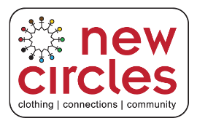  New Circles Community Services  161 Bartley Drive  Toronto, ON M4A 1E6  416 422 2591

Contact Information
Full Name
Street Address
City, Postal Code
Home Phone
Alternate Phone
E-Mail Address
Date of Birth (DOB) & Age
School Name

Interests

Tell us in which areas are you most interested in the LIST Program
Customer Service
Visual Merchandising
Stocking and Inventory
Loss Prevention
Diversity & Social Inclusion
Resume Writing
Mock Interviews
Placement in retail setting

Special Skills or Qualifications

Summarize special skills and qualifications you have acquired from employment, previous volunteer work, or through other activities, including hobbies or sports that would make you the ideal candidate for the LIST program

Previous Work/Volunteer Experience

Summarize your previous work/volunteer experience.

Person to Notify in Case of Emergency
Full Name
Street Address
City, Postal Code
Home Phone
Work Phone
E-Mail Address

Agreement and Signature

By submitting this application, I affirm that the information in it are true and complete. I hereby give permission to my child to participate in the Leaders In Service Training Program 2017 at New Circles Community Services.
Full Name (printed)
Parent/Guardian Name
Parent Signature
Date

Our Policy

It is the policy of this organization to provide equal opportunities without regard to race, color, religion, national origin, gender, sexual preference, age, or disability.

File Attachments
- Completed Application
- Resume
- 150 words describing why you’re interested in the LIST program

Send complete package to joanna@newcircles.ca by May 31, 2017.

Please note only selected candidates will be contacted to attend an interview.

